MOVING COIL GALVANOMETER (MCG)
A galvanometer is an electromechanical instrument used for detecting and measuring small electric currents. It works on the principle that a current-carrying coil placed in a magnetic field experiences a torque.

KEY COMPONENTS AND PARAMETERS
G or R₉: Internal resistance of the galvanometer coil.
I₉: Full-scale deflection current. This is the maximum current that can safely pass through the galvanometer to show a maximum reading.
k: Torsional constant of the spring.
n: Number of turns in the coil.
A: Area of the coil.
B: Magnetic field (usually radial).

WORKING PRINCIPLE
When current I flows through the coil, magnetic torque is balanced by the restoring torque of the spring:
nIAB = kθ
where θ is the deflection angle.
I = (k / nAB) θ
I = C θ (where C is the galvanometer constant).

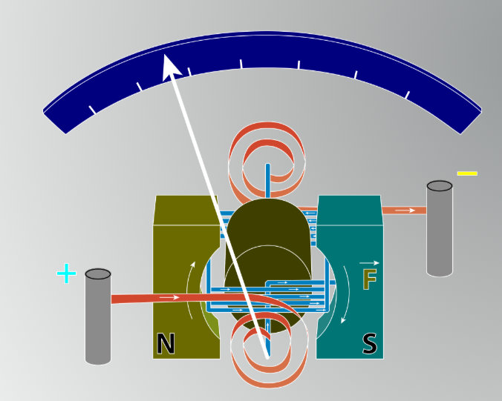

GALVANOMETER TO AMMETER CONVERSION
An ammeter measures large currents and must be connected in series in a circuit. To convert a sensitive galvanometer into an ammeter:
1. A small resistance called a Shunt (S) is connected in parallel with the galvanometer.
2. This parallel arrangement ensures most of the current flows through the shunt, protecting the galvanometer from damage.
3. The voltage across G and S is the same because they are in parallel.
Equation: I₉ * G = (I - I₉) * S
GALVANOMETER TO VOLTMETER CONVERSION
A voltmeter measures potential difference and must be connected in parallel. To convert a galvanometer into a voltmeter:
1. A very high resistance (R) is connected in series with the galvanometer.
2. This ensures the device draws minimal current from the circuit, avoiding "loading" effects.
3. The total current I₉ passes through both G and R.
Equation: V = I₉ * (G + R)

INTUITION AND CONCEPTUAL UNDERSTANDING
THE BYPASS ANALOGY (AMMETER)
Think of the galvanometer as a narrow, fragile pipe that can only handle a trickle of water (I₉). If you want to measure the flow of a massive river (I), you build a massive bypass canal (Shunt S) next to it. By measuring the tiny bit that goes through the narrow pipe, you can mathematically determine the total river flow without breaking the small pipe.

THE BARRIER ANALOGY (VOLTMETER)
A voltmeter is like a pressure gauge. To measure pressure (Voltage) between two points without letting all the water (Current) leak out of the main system, you place a massive barrier (High resistance R) in front of your gauge. This ensures only a "testing" amount of current enters the gauge to move the needle.

IDEAL VS. PRACTICAL
Ideal Ammeter: Has zero resistance (Rₐ = 0) so it doesn't change the circuit's current.
Ideal Voltmeter: Has infinite resistance (Rᵥ = infinity) so it doesn't draw any current.

FORMULA SHEET
MCG FUNDAMENTALS
- Current Sensitivity (Sᵢ) = θ/I = nAB/k
- Voltage Sensitivity (Sᵥ) = θ/V = nAB/(kG)
- Relation: Sᵥ = Sᵢ/G

AMMETER CONVERSION
- Shunt Resistance: S = (I₉ * G) / (I - I₉)
- Effective Ammeter Resistance (Rₐ): 1/Rₐ = 1/G + 1/S
- Approximate Rₐ: Rₐ ≈ S (since S is much smaller than G)

VOLTMETER CONVERSION
Series Resistance: R = (V / I₉) - G
Effective Voltmeter Resistance (Rᵥ): Rᵥ = G + R
Approximate Rᵥ: Rᵥ ≈ R (since R is much larger than G)

CONCEPT CONNECTIONS
OHM'S LAW AND NET RESISTANCE
Conversion problems are essentially applications of parallel and series circuit rules from Current Electricity.

SENSITIVITY VS. RANGE
1. To increase the range of an Ammeter (I), the Shunt (S) must be decreased.
2. To increase the range of a Voltmeter (V), the series resistance (R) must be increased.
3. Increasing current sensitivity by increasing "n" (turns) increases G. This might not increase voltage sensitivity because Sᵥ = Sᵢ / G.

JEE ADVANCED INSIGHTS
ERROR IN MEASUREMENT (LOADING EFFECT)
1. When a voltmeter is connected across a resistor, the parallel combination decreases the net resistance, leading to a measured voltage V_measured < Vₐctual.
2. Accuracy increases as Rᵥ / R_circuit increases.
N_DIVISIONS PROBLEMS
Sometimes I₉ is not given directly. Instead: "Current per division is 20 μA/div and there are 30 divisions."
I₉ = (Current/div) * (Total divisions) = 20 * 10⁻⁶ * 30 = 0.6 mA

HIGH-YIELD REVISION SHEET

MUST REMEMBER
Ammeter: Parallel Shunt (Small). Formula: S = I₉G / (I - I₉).
Voltmeter: Series Resistance (Large). Formula: R = (V/I₉) - G.
Ideal Ammeter: R = 0.
Ideal Voltmeter: R = infinity.
Sᵢ = NBA/k.
Sᵥ = NBA/kG.

LAST-MINUTE REVISION POINTS
- Shunt resistance S is always smaller than G.
- Voltmeter series resistance R is always larger than G.
- Adding a shunt decreases the overall resistance of the meter.
- Adding a series resistance increases the overall resistance of the meter.
- If current through galvanometer is 1/n of total current, then S = G/(n-1).
- If voltmeter range is increased n times, the added series resistance R=(n-1)G.

